1. We would like to solve:

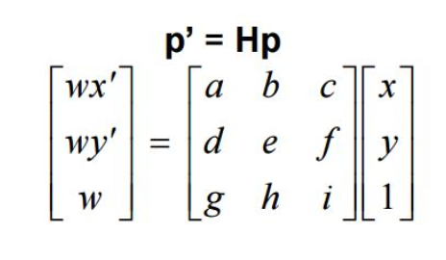

Where p are the source points and p’ are the destination points. We can solve for the homography matrix as follows:

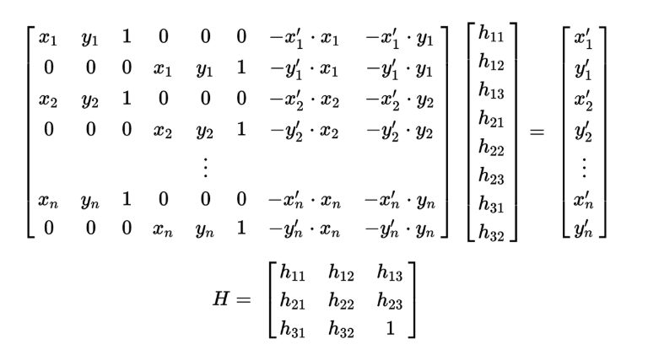

We will call the vector on the right hand side M2 (containing the destination points) and the matrix on the left hand side M1 and use the least squares methodology to find H as follows:

H = ( M1 transpose * M1 )inv * ( M1 transpose * M2)

1. See code
2. H = [ 1.39472444e+00 2.01438863e-01 -1.23828556e+03]

[ 3.84188164e-03 1.30716833e+00 -7.80395273e-01]

[ 3.55783803e-04 4.19398052e-05 1.00000000e+00]

1. The image received is :

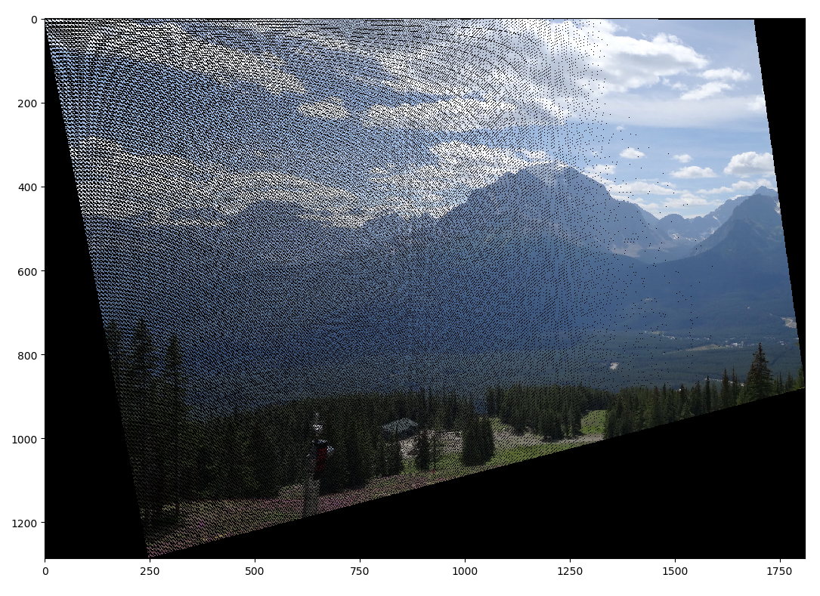

1. The transformation is not smooth meaning we have “holes” in the target image because the range of the transformation appears to be larger than the domain so that the number pixel transformed is not sufficient. The shape of the new image is not rectangular. Furthermore, the holes appear to be located mostly on the left side and are not evenly spread.

Our New H (calculated using “matches” containing outliers):

[-3.21938547e-02 -5.88287579e-02 1.02051638e+02]

[-3.95818251e-01 4.47497305e-02 4.82946288e+02]

[-6.30013633e-04 -2.49197318e-04 1.00000000e+00]

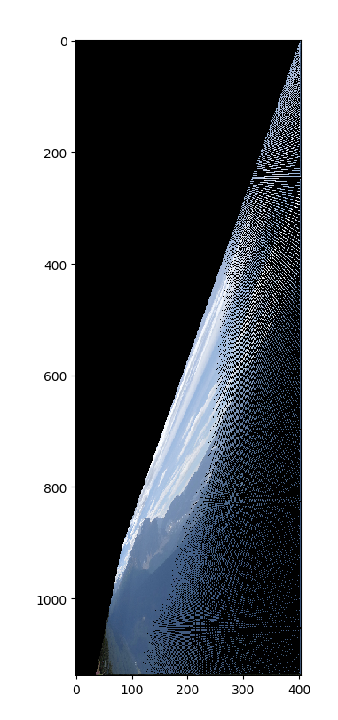We got the following image mapping:

We can see that most of the pixels were not mapped to the valid pixel range and therefore the target image is significantly smaller the “holes” artifact is also apparent here and was even increased.

**PART B**

1. See code
2. See code

$K=\frac{\log{(1-P)}}{\log{(1-W^{n})}}$

K – number of needed randomizations to guarantee the needed level of confidence.

P - success confidence guarantied

W – inliers percent

n – minimum number of points required to compute the homography matrix.

For n= 4 and w = 0.8 , p= 0.9 we get k ~ 5

For n= 4 and w = 0.8 , p= 0.99 we get k ~ 9

In order to cover all possibilities for say 30 data points while in each iteration we choose 4 points we use “m choose 30”: $\left({30 \atop 4}\right)=27405$

1. Received best H:

[ 1.40758885e+00 2.52105630e-01 -1.27402138e+03]

[-1.14219346e-01 1.51415480e+00 1.98605308e+01]

[ 2.26128168e-04 3.09585640e-04 1.00000000e+00]

Homography image obtained with RANSAC for n = 10:

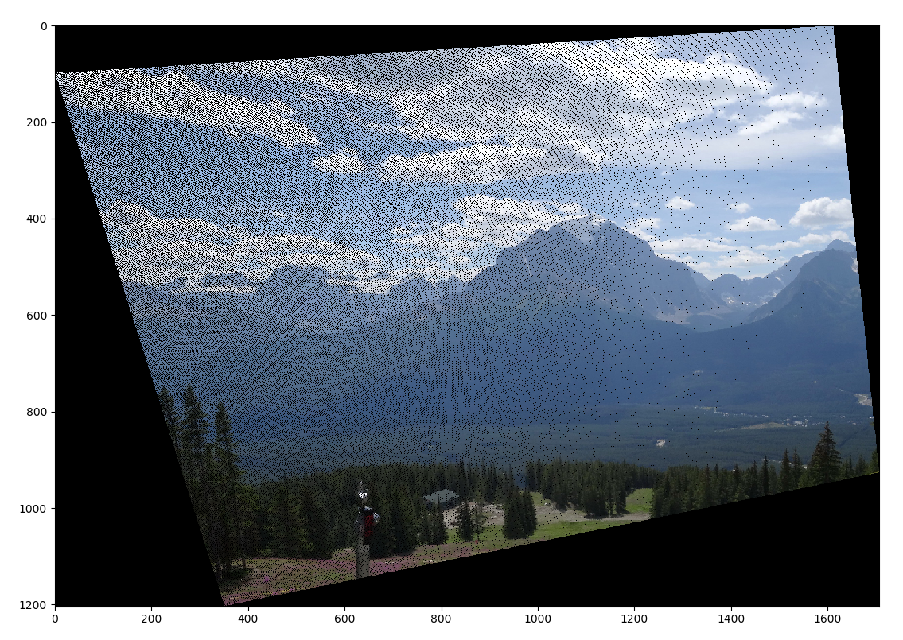

We can see that in comparison to the computation with outliers without implementing RANSAC (6) we got a significantly improved result seeing as the outliers we mostly neglected while calculating H_RANSAC and therefore our result is much similar to the naïve forward mapping seen in 4.

1. 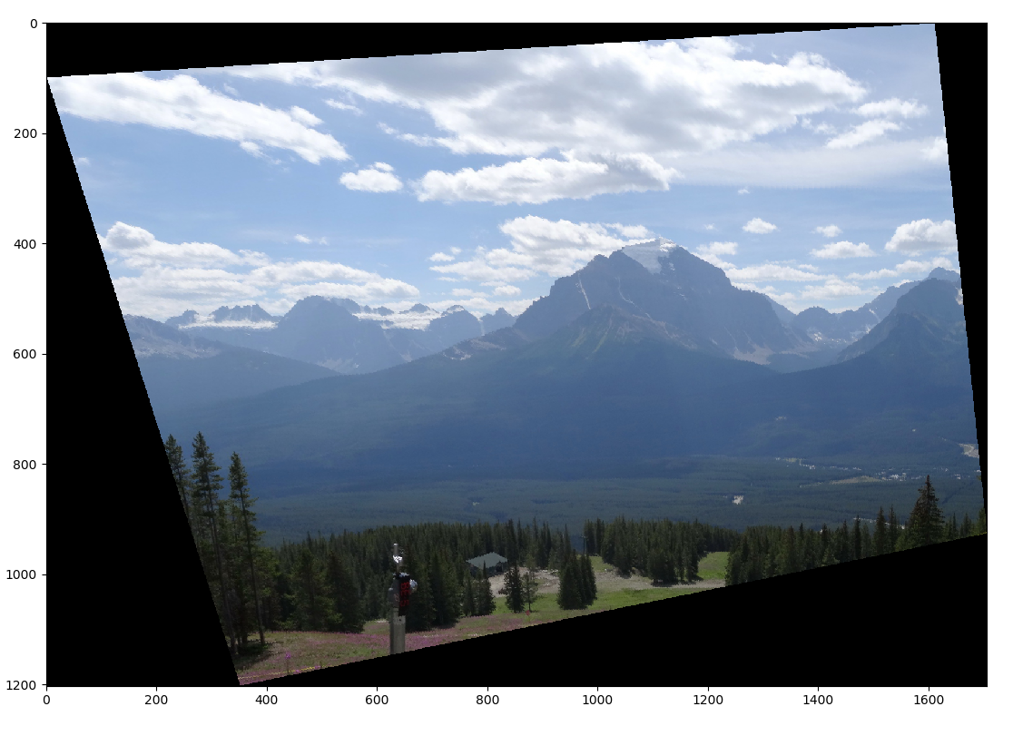One can easily see that the quality of the image was improved, the image is much smoother (no holes) in compression to the one in section 10 due to the bilinear interpolation.

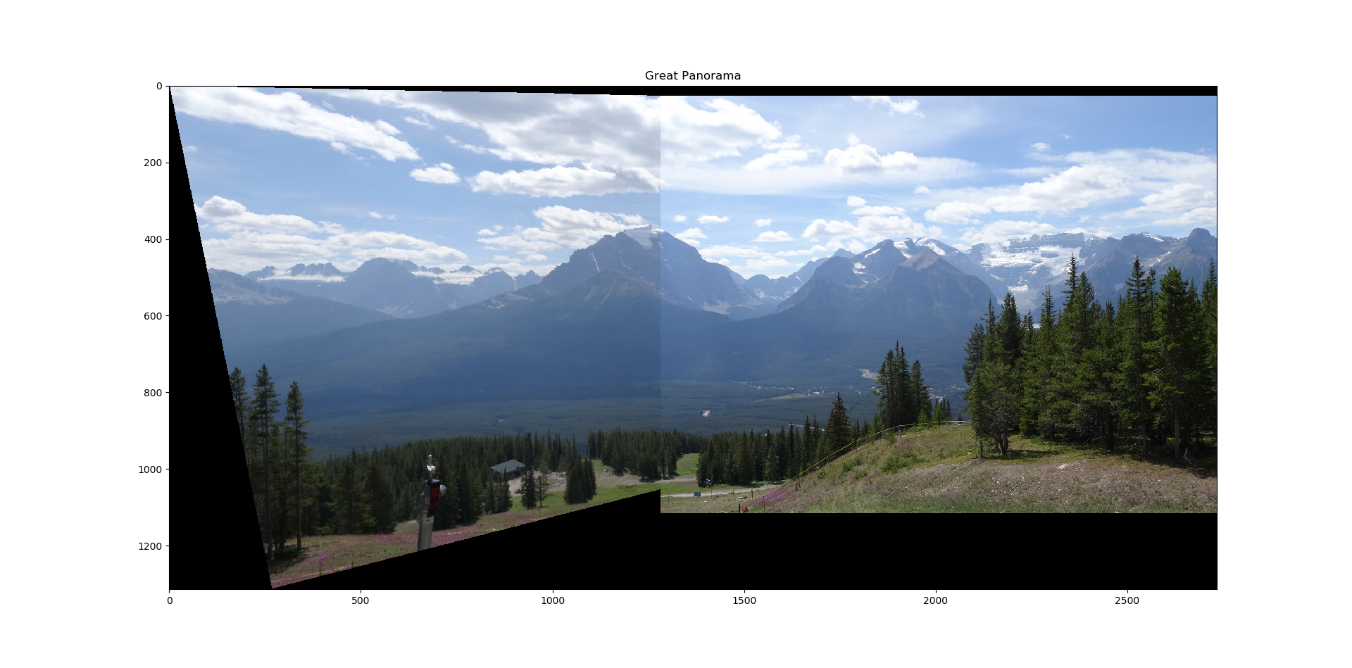

1. See code
2. Panorama image:
3. 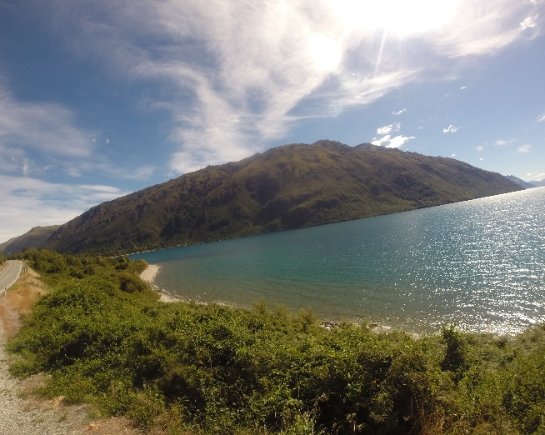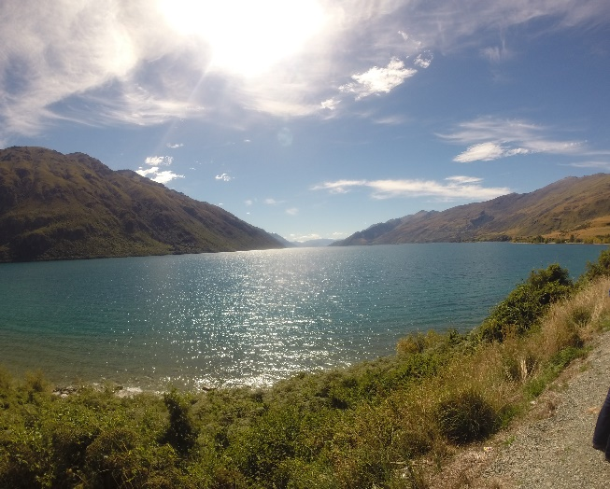The following images were used to compute the panorama:

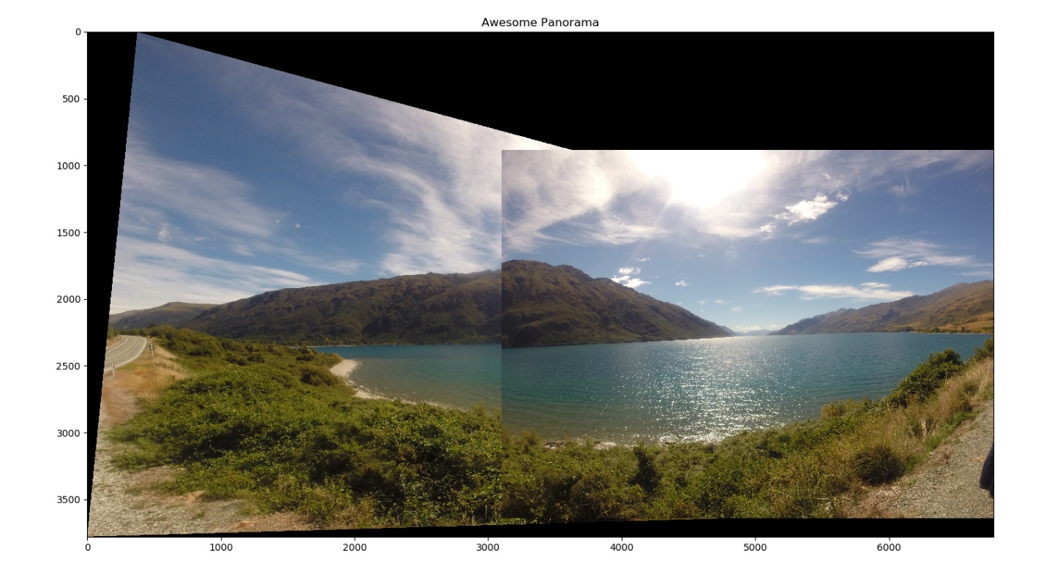Following is the panorama received: